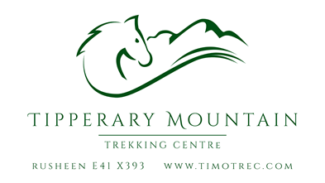

**AGREEMENT FOR A PLACE ON A RESIDENTIAL PONY CAMP**

**FROM 7.30 pm on SUNDAY to 5.30 pm on FRIDAY**

**Between**

**(Name of Parent)**

**And**

**Tipperary Mountain Trekking Centre**

This agreement is in relation to the provision of a place on a residential pony camp at Tipperary Mountain Trekking Centre.

Please indicate which camp you would like to attend:

|  |  |  |  |
| --- | --- | --- | --- |
| 16th – 21st February |  | 27th July – 1st August 2025 |  |
| 20th April – 25th April 2025 |  | 10th August – 15th August 2025 |  |
| 6th July – 11th July |  | 27th October – 31st October 2025 |  |
| 13th July – 18th July 2025 |  |  |  |

|  |  |  |  |  |  |
| --- | --- | --- | --- | --- | --- |
| Rider Surname | First Name | Age in June 2025 | Height | Weight | Sex |
|  |  |  |  |  |  |

|  |  |
| --- | --- |
| Parent’s full name |  |
| Address including eircode |  |
| Mobile phone |  |
| Email |  |
| Emergency name and contact number |  |

Tipperary Mountain Trekking Centre is annually approved by the Association of Irish Riding Establishments. The instructors are Dr. Clare Leon (LLB, MPhil, PhD, AIRE Approved Instructor) and Ms. Lilyana Leon (BA, MSc, BHSAI). It is a condition of our approval that both instructors have child safeguarding certification. Our formal child safeguarding policies are available on request.

Our Services

Tipperary Mountain Trekking Centre will provide care, including food and accommodation, and instruction for the above-named child at a residential pony camp being held at Tipperary Mountain Trekking Centre. Accommodation will consist of a bed in a room shared with other girls participating in the camp. Boys will have separate shared accommodation.

1. Bedtime is at 9pm. No food is allowed in the bedroom.
2. Chewing gum is not allowed.
3. Meals consist of a breakfast of cereals/toast/yoghurt/hot drinks. Lunch is sandwiches, fruit etc and crisps are also provided, but children can also bring their own favourite snacks. A cooked dinner is provided each evening, except Sunday and Friday. Meals are meat-free but may contain dairy, eggs and fish.
4. Please let us know in advance if your child has any special dietary needs. Please note that we cannot cater for serious dietary allergies.
5. Tipperary Mountain Trekking Centre will provide instruction in horse handling and horse riding as they deem appropriate, safe and feasible, for the child. Typically this will constitute eight mounted lessons and eight stable management lessons from Monday to Thursday, with show preparation and a gymkhana on the final Friday.

Your Commitments

1. The parent warrants that the child has no special dietary or accommodation needs.
2. The parent warrants that the child has no special physical or emotional needs.
3. The parent warrants that the child has her/his/their own personal injury and medical insurance.
4. The parent warrants that the child can speak and understand English and understands English equestrian terms.
5. In the event that, on the determination of Tipperary Mountain Trekking Centre, the child cannot happily participate in the camp due to homesickness, unruly or disobedient behaviour, injury or illness, the parent will make all necessary arrangements for their immediate medical attention and, if necessary, immediate return home.
6. Tipperary Mountain Trekking Centre accepts no responsibility, and cannot be held liable, for any arrangements made by the parent and a third party for transport to or from the Centre, or for accommodation not on the Centre’s premises.
7. The child should bring their own riding helmet, gloves, riding boots, wellingtons, jodhpurs and back protector. Helmets and back protectors must conform to current safety standards. It is not permitted to ride with whips or spurs at Tipperary Mountain Trekking Centre.
8. Other clothing: Irish weather is notoriously unpredictable. We recommend that the child brings at least 3 pairs of jodhpurs, jumpers and a spare waterproof jacket, as well as T-shirts, underwear, pyjamas and slippers, sunglasses and suncream.
9. Horse-riding is deemed to be a high risk activity. The parent voluntarily assumes this risk on behalf of their child.
10. The parent must complete and sign the attached registration and waiver form and return it immediately to the service provider, by email to [info@timotrec.com](mailto:info@timotrec.com). It is the parent’s responsibility to make the child aware of the terms and conditions in the waiver form.
11. The parent must also return a signed copy of this agreement, by email, to [info@timotrec.com](mailto:info@timotrec.com).

Payment and acceptance of terms

1. The cost of a place at the camp is €675. A 25% non-refundable booking deposit of €168 is payable immediately to

BIC: AIBKIE2D IBAN:IE55AIBK93530132932041. The balance of €507 should be paid on or before a week in advance of the commencement of the camp. Please ensure the rider surname and camp start date is on our statement (eg: Leon 10th August)

*We offer a 10% discount for second and subsequent family members. Contact us if this applies to you.*

Payment of the booking deposit will be deemed to be acceptance of these terms and conditions.

Signed: Clare Leon

Clare Leon, Owner/Manager,

Tipperary Mountain Trekking Centre.

Dated: 11th January 2024

Signed: (Parent)

NAME:

Dated:

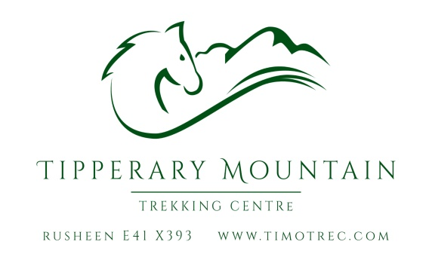

**REGISTRATION AND WAIVER FORM:**

Name: Age:

Address:

Mobile: Email:

1. **MEDICAL HISTORY**

***Do you now, or have you ever, suffered from any medical condition which could affect your fitness to ride?***

1. **NO or**
2. **YES**

If ‘**YES’**, please circle the condition concerned: ASTHMA; DIABETES; EPILEPSY;HEART PROBLEMS; BACK PROBLEMS; FAINTING; OSTEOPOROSIS; OTHER (state):

**AND** My doctor agrees that it is safe for me to go horse-riding.

Name of doctor: Ph:

## RIDING EXPERIENCE

***Please circle the level that most closely describes your riding experience. Underestimate, rather than overestimate, your ability:***

**Beginner** (I have ridden on a lead-rein)

**Novice** (I am competent in walk and trot off a lead rein, in open country, on a variety of different horses)

**Intermediate** (I am competent in walk, trot and canter, in open country, on a variety of different horses)

**Advanced** (I frequently go competing at 1m +, or hunting)

Please read and sign below to show that you accept our terms, conditions and waiver. In the case of a child age under 18, parents/responsible adults must sign in BOTH places on this form on their behalf

**TERMS AND CONDITIONS**

1. Management reserve the right to refuse an applicant permission to ride at this establishment.
2. The ‘RIDING EXPERIENCE’ section of this form, giving **accurate** information on previous riding experience, must be completed before acceptance. Horses will be matched to riders in accordance with the rider’s statement of experience.
3. Regulation headwear, footwear and clothing must be worn. Headwear and footwear brought by clients may be examined by management for suitability.
4. Scarves and dangling or bulky jewellery must be removed before riding. You ride with body piercings at your own risk.
5. ALL instructions from management and staff must be followed meticulously in the interest of safety.
6. Riders are recommended to have Personal Accident Insurance Cover.

**DECLARATION AND WAIVER**

“I hereby apply to participate in equestrian programmes or activities organised by Tipperary Mountain Trekking Centre. I have completed this application form giving full details of my riding experience and I understand that this will form the basis of the agreement between the Trekking Centre and myself. I understand, accept and agree:

1. That all sporting activities have an element of danger and that riding is no exception.
2. That I may suffer serious personal injury, as well as loss of property, as a result of exposure to the risks and hazards associated with riding as a sport, and I voluntarily assume all of these risks and hazards.
3. That Tipp
4. That I will abide by all rules and regulations laid down by Tipperary Mountain Trekking Centre and will follow all instructions meticulously.
5. That by accepting these terms and conditions and by signing this agreement below, no liability shall attach to Tipperary Mountain Trekking Centre, its proprietors or management, for any injury, loss or damage however sustained.
6. That nothing in this agreement is intended to exclude my statutory rights.

SIGNED (Parent/Responsible Adult): Dated:

TO BE COMPLETED BY THE RESPONSIBLE ADULT ON BEHALF OF A RIDER AGED UNDER 18:

“I undertake that the above named child will follow all instructions outlined in this form. I am competent to complete the form on her/his/their behalf. I understand that riding is a risk sport and accept that no liability shall attach to Tipperary Mountain Trekking Centre for any injury loss or damage however sustained, subject to my statutory rights.”

SIGNED: DATED:

RELATIONSHIP TO CHILD:

IF NOT PARENT, PLEASE PRINT YOUR NAME AND ADDRESS BELOW: