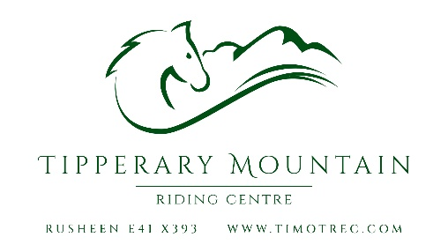
ADULT CAMP BOOKING FORM 2026

YOUR PREFERRED DATES:
Surname | First Name | Height | Weight

Address including eircode:
Mobile phone:
Email:
Emergency contact number:
Please describe your riding experience:

Camp goals:

PRICES | All lessons, treks and lunch | € | Deposit | Balance
Hired Horse | No accommodation | 420 | 105 | 315
 | Full board shared accommodation | 600 | 150 | 450
 | Full board private room | 705 | 175 | 530
Own horse including livery | No human accommodation | 420 | 105 | 315
 | Full board shared accommodation | 600 | 150 | 450
 | Full board private room | 705 | 175 | 530

Tipperary Mountain Riding Centre is annually approved by the Association of Irish Riding Establishments. The instructors are Dr. Clare Leon (LLB, MPhil, PhD, AIRE Approved Instructor) and Ms. Lilyana Leon (BA, MSc, BHSII).

Terms and conditions

- We can loan suitable riding helmets and boots if necessary, but we recommend that you bring your own riding helmet, gloves, riding boots, wellingtons, jodhpurs and back protector. It is not permitted to ride with whips or spurs on our own horses at Tipperary Mountain Riding Centre.

- Horse-riding is deemed to be a high risk activity. By returning the booking form, you voluntarily assume this risk. Please also complete and return the attached waiver form.

- We strongly recommend that you have your own personal accident insurance that covers equestrian activities.

- Meals provided by the centre are meat-free but may contain eggs and dairy. If you have any special dietary needs please let us know here:

- Health issues. You are responsible for your own health, safety and comfort. Adult camps are very intensive. If you have any health issues that could affect your enjoyment of our lessons and treks, please let us know. Similarly if you are a nervous rider, or have experienced a bad fall, let us know. We will do our best to accommodate your needs, subject to the needs of the group.

- Schedule. The schedule for the camp is flexible and based on the riders’ stated goals. You will receive approx. 8 hours mounted group instruction and one hour private, but the format (lesson or trek) may change depending on the requirements of the group and on weather conditions.

- Deposits and refunds. We require a 25% deposit to secure your place. This is refundable up to six weeks in advance of the camp start date, less a 10% admin fee. After this date it is not refundable. The balance is due one week in advance and must be paid in full by the start of the camp. It is not refundable.
Payment and acceptance of terms
- To secure your place, please pay the relevant booking deposit to
BIC: AIBKIE2D IBAN:IE55AIBK93530132932041. The balance can be paid in cash at the commencement of the camp, or in advance by bank transfer. Please ensure your surname appears on our statement, with the code AC and the month of the camp (eg: Murphy AC June).

- Payment of the booking deposit will be deemed to be acceptance of our terms and conditions.

